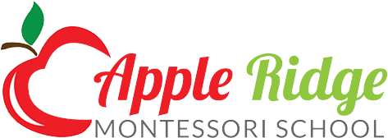

200 Ingleside Avenue
Catonsville, Maryland 21228
Phone #410-818-2000
e-mail: info@appleridgemontessori.org

Application

Name of child _________________________________________________________________________
First Middle Last Birth Date

Address ________________________________________________________________________________
Street City State Zip Code
Home Phone _______________________________

Parent Information:

Mother _______________________________ Father _______________________________

Name _______________________________ Name _______________________________

Occupation _______________________________ Occupation _______________________________

Phone _______________________________ Phone _______________________________

E-mail _______________________________ E-mail ___________________________________

Child's previous experience outside the home:
________________________________________________________________________________
________________________________________________________________________________

Preferred Start [ ] Fall Session [ ] other
Program [ ] Half day [ ] Full Day

If you require before and after school care Please specify hours. ___________________________________

Date__________________ Signature ___________________________________________________

The Apple Ridge Montessori School is non-sectarian. We admit students of any race, religion or national origin.

Please return the application form with the one-time application fee of $50.00

How did you hear about Montessori?
Newspaper (name of paper)______________ Telephone Book (which one) ________________ Internet ______________________

Friend/Relative _____________________________ Other ___________________________________

